The Royal United Services Institute of Regina
#14 105 Angus St
Regina SK S4R 3L4

18 December 2021

COMMEMORATIVE PEDESTALS PROJECT

In the winter of 2019 the idea of the Commemorative Pedestals was hatched. The premise is, that most visitors to Regina’s Victoria Park when seeing the Cenotaph understand that it is about remembering our Veterans but few really understand what they should be remembering. With the Veterans of the Second World War and Korean War fast disappearing they will no longer be able to tell their own stories. The plan is to erect pedestals at the Cenotaph that would tell the stories of our Veteran’s sacrifices in Canada’s wars and battles. The pedestals would have to complement the Cenotaph, be eye catching and stand the test of time. Their mission; to educate the public, especially the youth, about what Canada’s Veterans have sacrificed for their futures. It is hoped that, when completed, school classes will tour the pedestals and speak with the new generation of Veterans. This project will go a long way to satisfying our mission of “honouring the Canadian Armed Forces and its members past and present”.

In the spring of 2020 the project was posed to the local Legion branch for their blessing, which was given. Negotiations were then held with the City to agree upon a location to place them and an acceptable appearance and material for the pedestals. It was agreed that the pedestals would be placed on the cement platforms at the ends of two flower planters to the south-east and south-west of the Cenotaph. The pedestals would be made of granite to match the Cenotaph and be 16 inches square with a slanted face. On the face would be a plaque made of black polished granite with the message laser engraved.

The next step was determining the messages to be displayed. Space on the two planters allowed for six pedestals on each one. The first two pedestals were to be ARMISTICE DAY, recounting the First World War and VE DAY for the Second World War. The cost of each pedestal was determined to be roughly $3,600. The RUSI, from its commemoration fund, produced the first two Commemorative Pedestals. They were unveiled by the Lieutenant Governor, His Honour the Honourable Russ Mirasty, on 10 November 2020.

The plan was to raise $7,200 a year so as to fund the remaining 10 pedestals over a five year period. However, due to a grant from Veterans Affairs Canada and donations from individuals and Commissionaires South Saskatchewan, by March 2020 all 10 remaining pedestals were funded. They were unveiled two at a time over five ceremonies from 27 July to 8 November 2021. These 10 pedestals were: KOREAN WAR, D DAY, PEACEKEEPING, VIMY RIDGE, AFGHANISTAN, RCAF IN THE SECOND WORLD WAR, BATTLE OF THE ATLANTIC, DIEPPE RAID, INDIGENOUS VETERANS and SOUTH AFRICAN WAR.

These pedestals, with their messages, will help visitors to the park keep the memory of our Veterans and the debt of remembrance we owe them for decades to come.
PEDESTALS D Day and Korean War

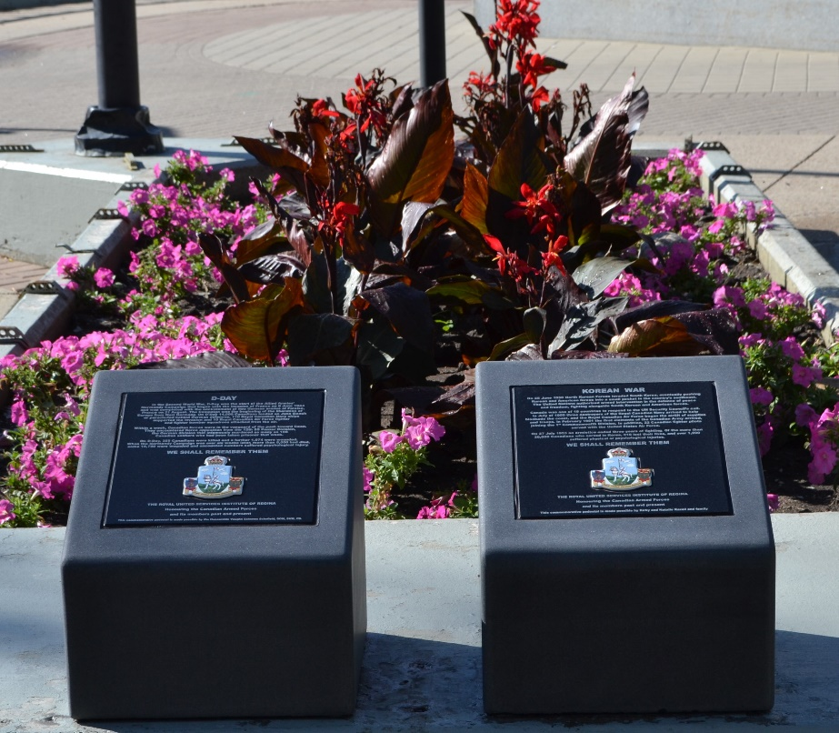

UNVEILING 27 July 2021 Ceremony

